**Setting Up JUnit**

To configure JUnit in a Java project using Maven and verify that unit testing works via a sample test class.

**Tools Used:**

* **IDE**: IntelliJ IDEA
* **Build Tool**: Maven
* **Testing Framework**: JUnit 4.13.2
* **Language**: Java

**Steps Followed:**

1. **Created a Maven-based Java Project**
   * Project name: JUnitDemo
   * Structure: followed Maven conventions (src/main/java and src/test/java)
2. **Added JUnit Dependency to pom.xml**

<dependency>

<groupId>junit</groupId>

<artifactId>junit</artifactId>

<version>4.13.2</version>

<scope>test</scope>

</dependency>

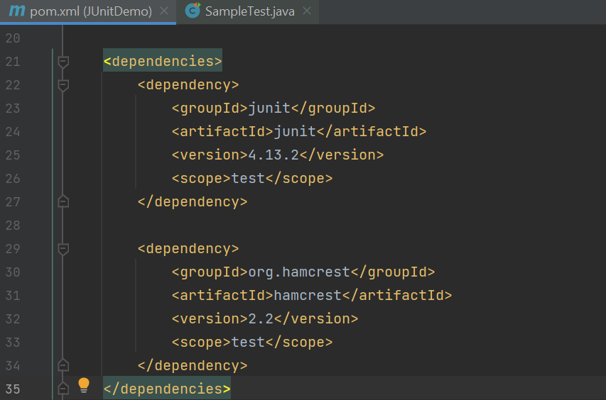

1. **Created a Sample Test Class in src/test/java**
   * File: SampleTest.java

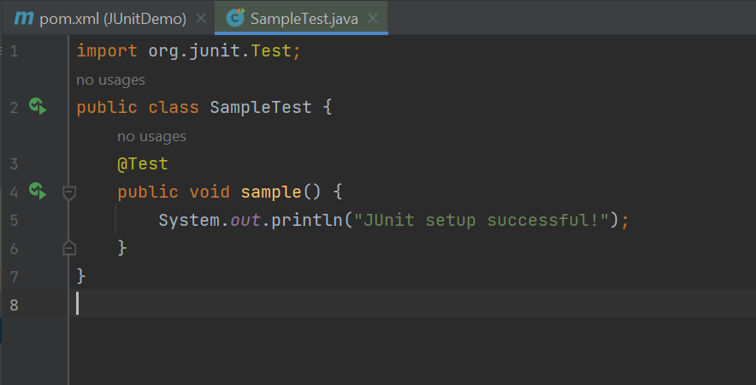

* + Used @Test annotation from JUnit
  + Method printed confirmation message

1. **Executed Test**

Output verified in IntelliJ:

